CHM 1040. GENERAL CHEMISTRY II LAB
WEEK 6. CHAPTER 15. CHEMICAL EQUILIBRIUM
NAME: ______________________

Solve the following problems from your textbook. (10 points each)
- Practice Exercise on Page 520 (First solve Example 15.1 and then attempt the practice exercise).

K_{c} = [NO₂]⁴[O₂]
[N₂O₅]²

K_{p} = P ⁴_{NO2}× P_{O2}
P ²_{N2O5}

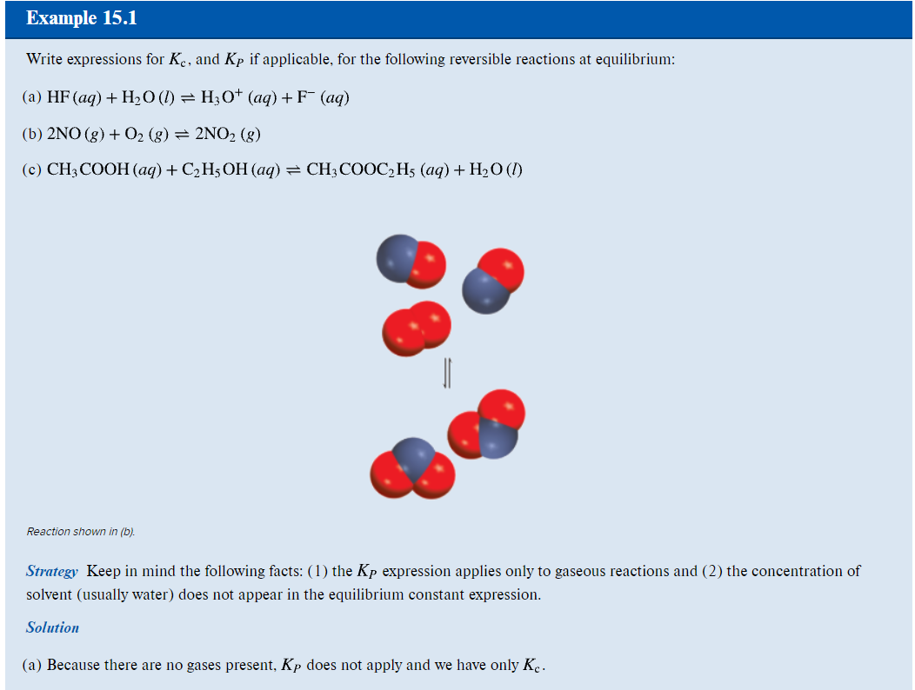
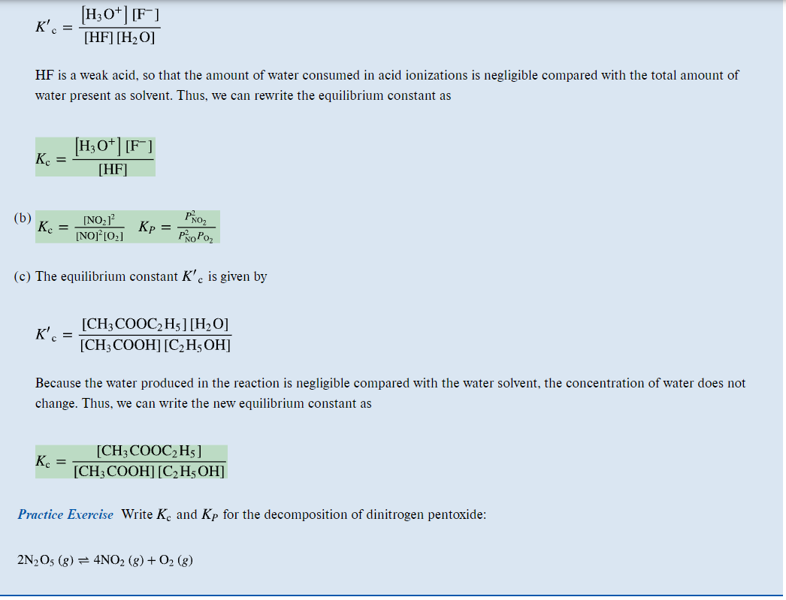
- Practice Exercise on Page 520 (First solve Example 15.2 and then attempt the practice exercise).

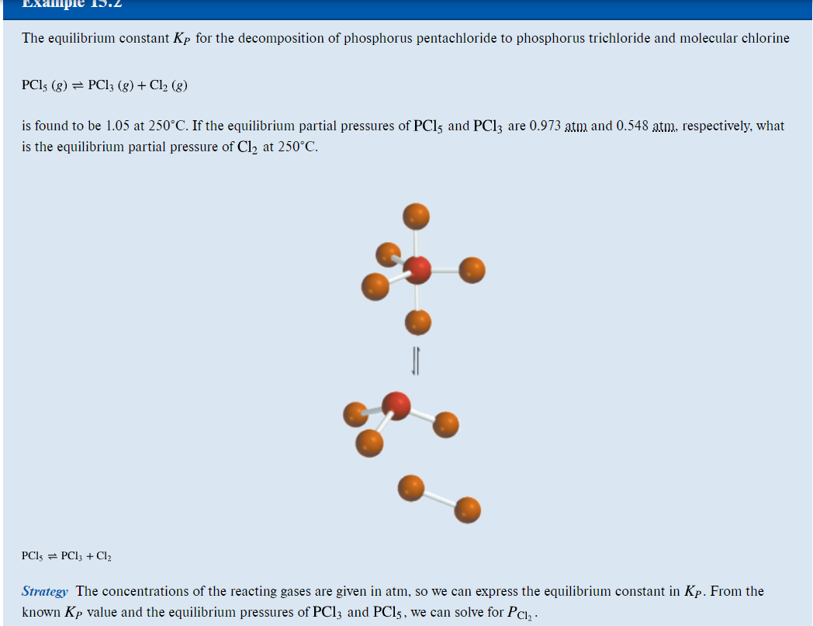

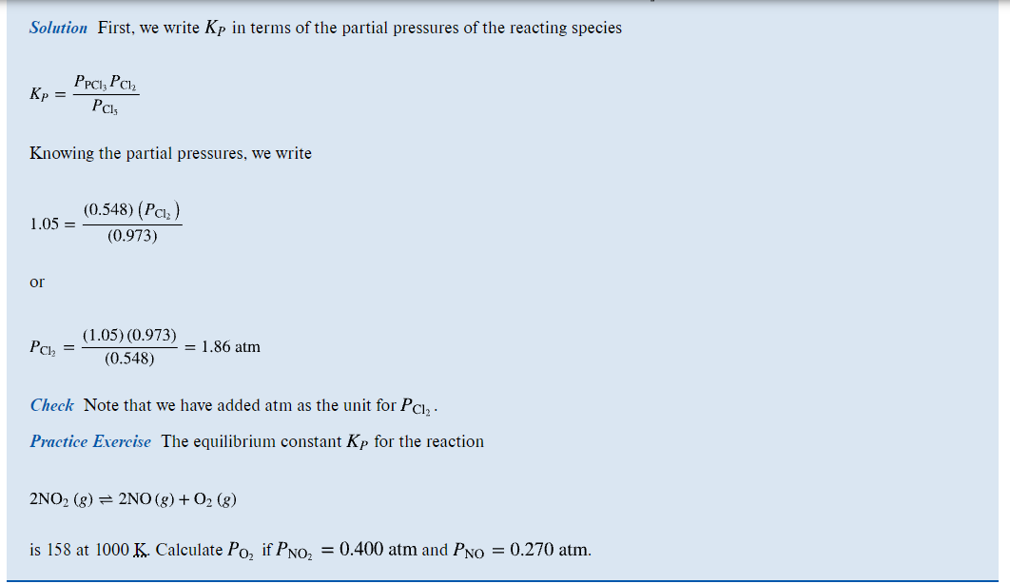

Answer to question 2
K_{p}= P²_{NO}×P_{O2}
P²_{NO2}

P_{O2} =(0.4)² ×158
0.27²

P_{O2}= 346.776 atm

3.Practice Exercise on Page 521 (First solve Example 15.3 and then attempt the practice exercise).
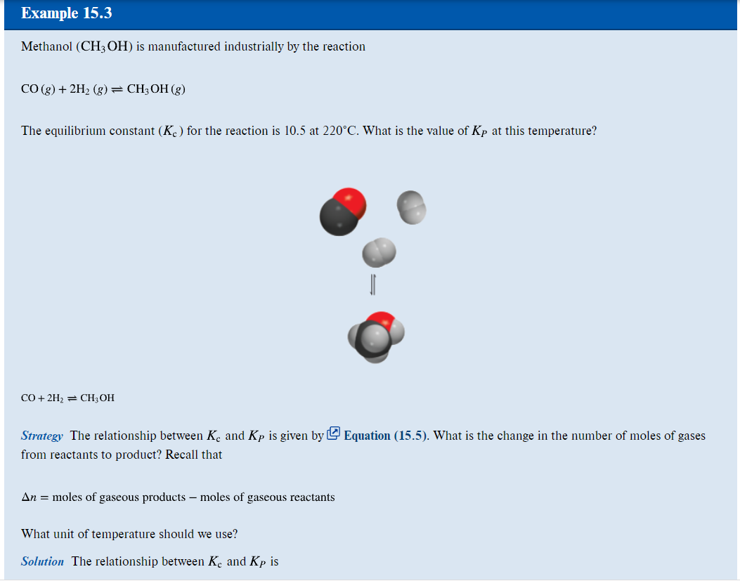
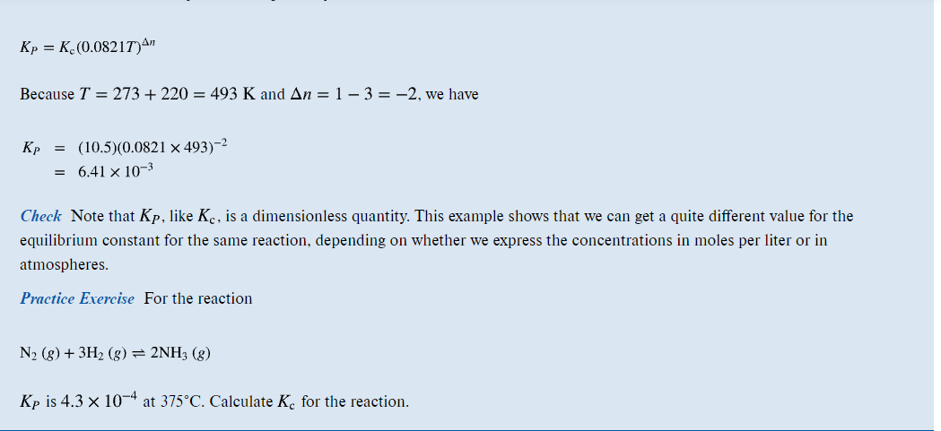
Answer to question15. 3

T=375+273 =648K
Δn=2-4
Δn=-2
Kc =4.3 X 10⁻⁴
(0.0821X648)⁻²
K_{C} =1.22

- Practice Exercise on Page 523 (First solve Example 15.4 and then attempt the practice exercise).
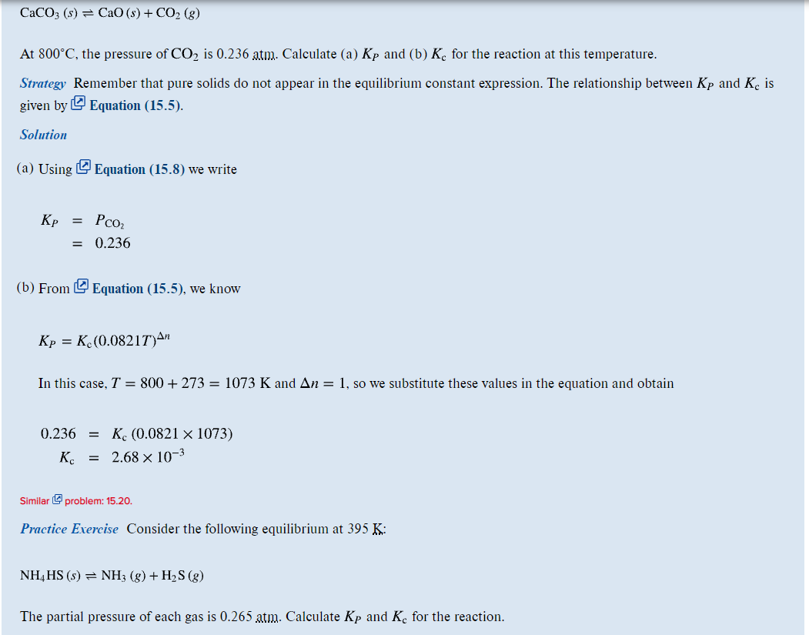

K_{p}=P_{NH3} x P_{H2S}
K_{P}=(0.265 X0.265)
K_{P}=0.070225

K_{p}=K_{c}(0.00821 X T) ^{Δn}

where Δn=2-1=1 and T=395K

K_{c} = 0.070225÷(0.00821X395)¹

K_{c}= 2.158 X 10⁻³

5.Practice Exercise on Page 531 (First solve Example 15.8 and then attempt the practice exercise).

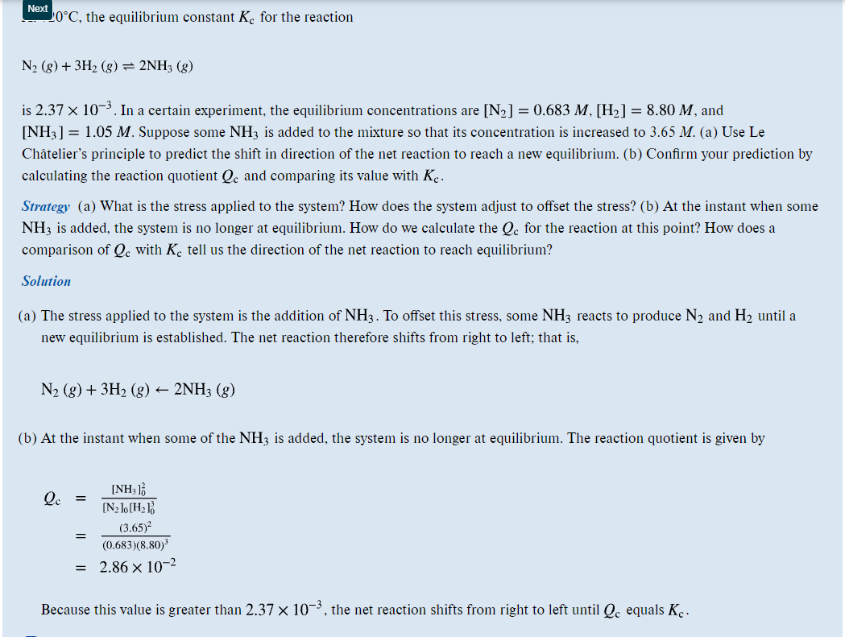
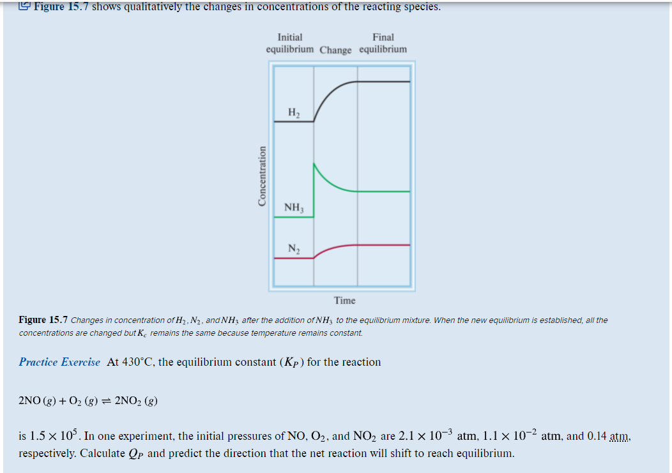

- Practice Exercise on Page 533 (First solve Example 15.9 and then attempt the practice exercise).

Q_{P}= [ P_{NO2}]_{o}²
[ P_{NO} ] _{o}² X [ P_{O2}]_{o}
Q_{p}= ( O.14) ²
( 2.1X10⁻³ )² X 1.1X10⁻²
K_{p}=4.04 X 10⁵
II) The value of Q_{p} is > than K_{p} hence the equilibrium shift from right to left until Q_{p} equals K_{p}

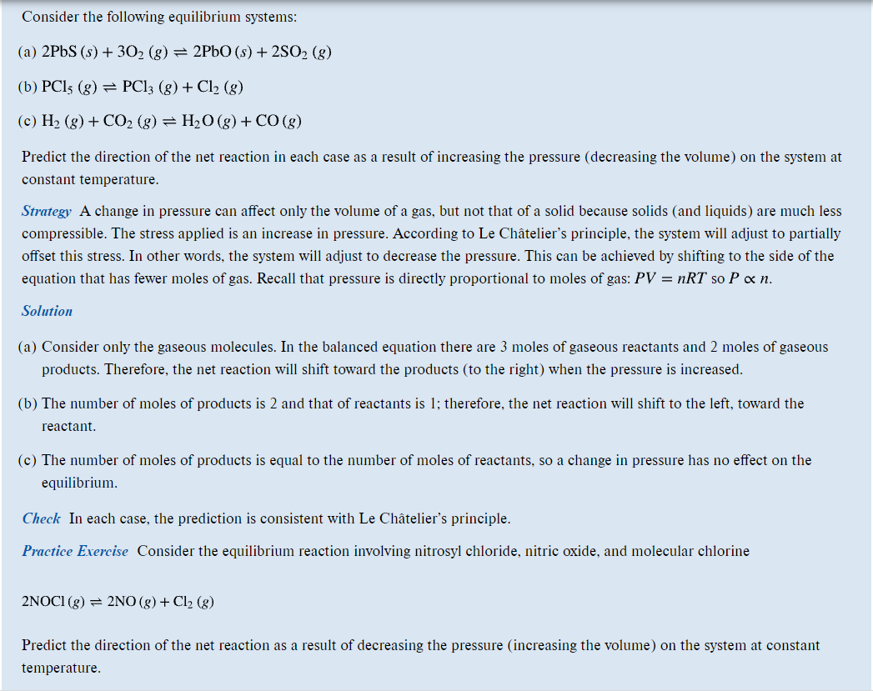

- Problem 15.7 (Similar to Example 15.1).
A decrease in pressure will favour the direction with high gaseous volume hence a decrease in pressure results to the equilibrium shifting from LEFT to RIGHT .This results to decomposition of nitrosyl chloride forming nitric oxide and chlorine
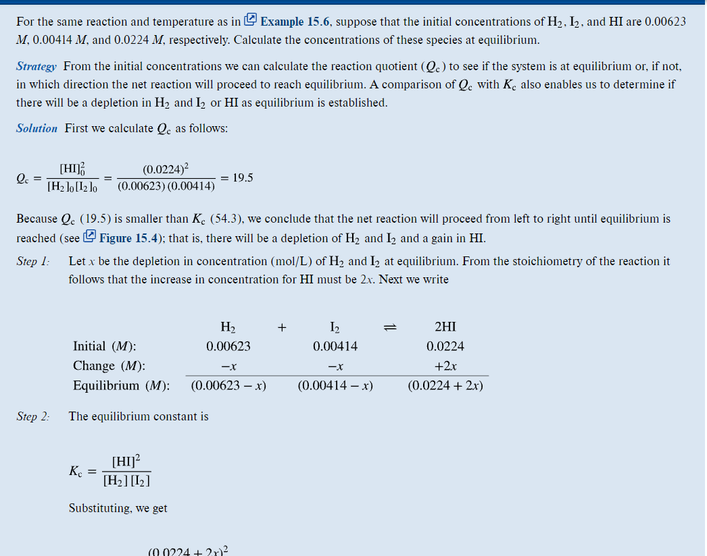
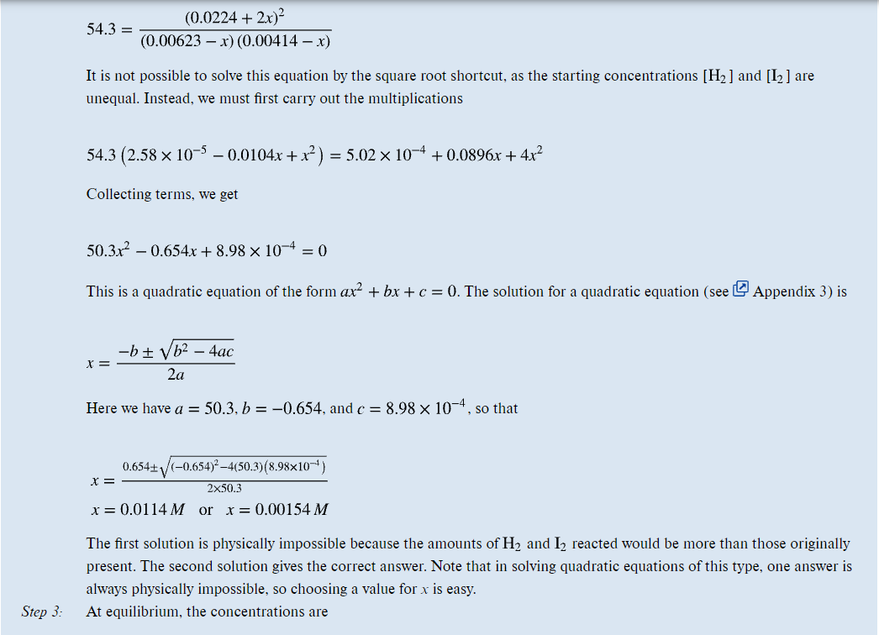
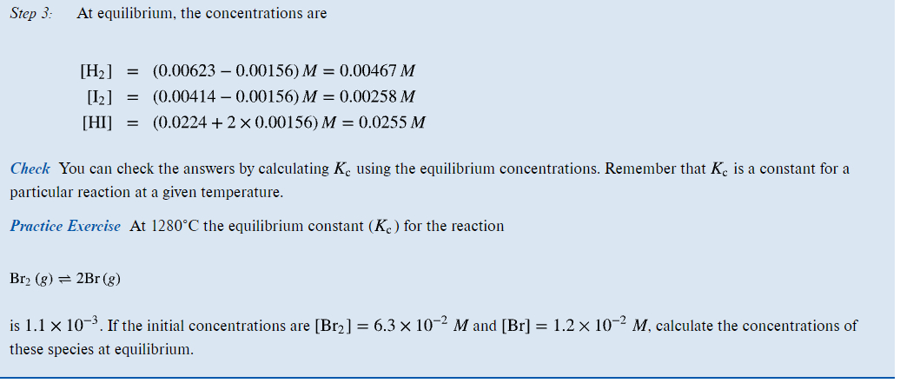

Question 7 solution
Br₂(g) ⇌2Br(g)
Let x be the depletion of concentration in mole /l
The [Br2]=(0.063-x)
[Br2]=(0.012+2x)

Kc= (0.012+2x)² the value of kc =0.0011
0.063-x
0.0011= (0.012+2x)²
0.063-x

0.0011(0.063-x)= 0.000144+0.048x+4x²

6.93X10⁻⁵ -0.0011X = 0.000144+0.048x+4x²

0.0000747+0.0491x +4x² =0
ax2 + bx + c= 0 rearranging it
4x2+0.0491x+0.0000747 =0
Substituting the values in the equation :
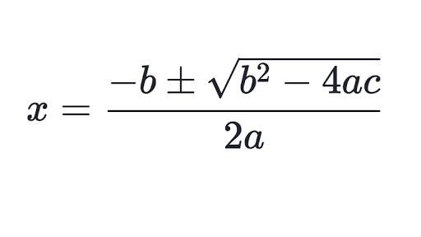
Solving for x using the quadratic equation
x= -0.0017793
x=−0.0104957

the value of x is =-0.0017793
at equilibrium the

[Br2]=0.063-(-0.0017793)= 0.0647793mol/L
[Br2]=(0.012+2(-0.0017793)=0.0084414Mol/l

kProblem 15.8 (Similar to Example 15.1).
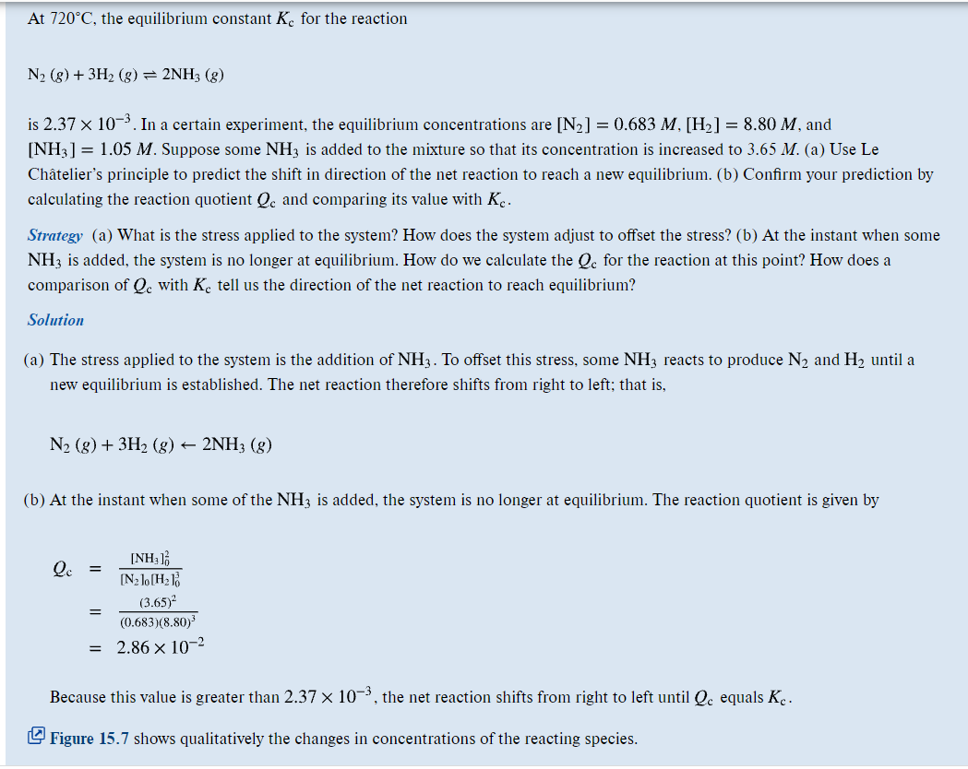

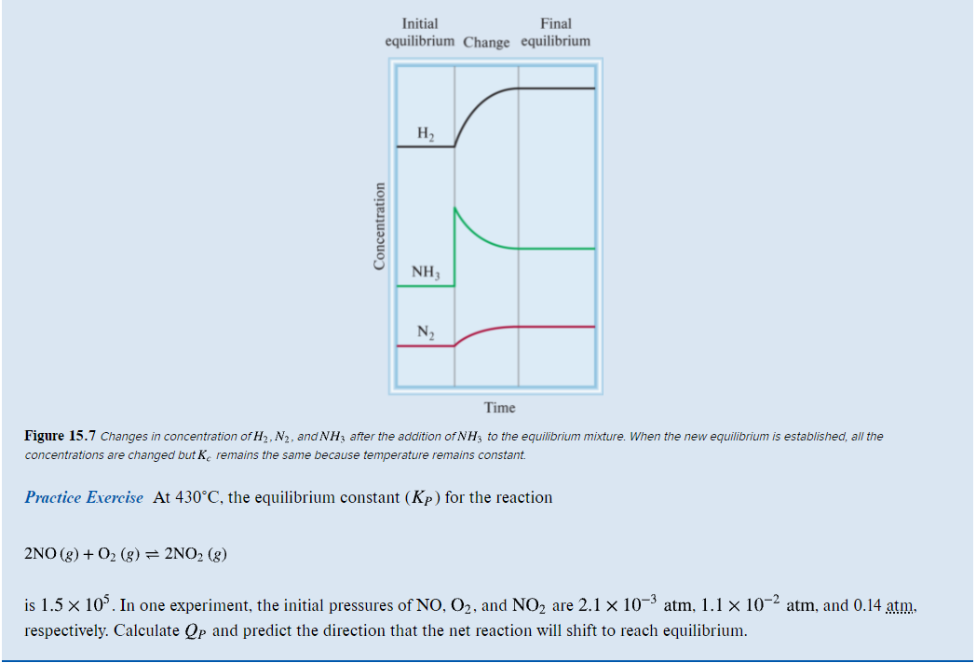
- Problem 15. 15 (Similar to Example 15.3)

Q_{P}= [ P_{NO2}]_{O}²
[P_{NO} ]²₀ X [ P_{O2}]
Q_{p}= ( O.14) ²
( 2.1X10⁻³ )² X (1.1X10⁻²)
K_{p}=4.04 X 10⁵
II) The value of Q_{p} is > than K_{p} hence the equilibrium shift from right to left until Q_{p} equals K_{p}

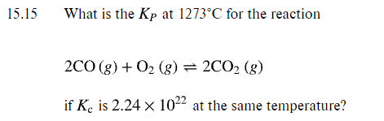

K_{p}=K_{c}(0.00821 X T) ^{Δn}

where Δn=2-3=-1 and T=1546K

K_{p}=2.24 X 10²²(0.00821 X 1546) ⁻¹

Kp=1.764 X10²⁰
Problem 15. 16 (Similar to Example 15.3)
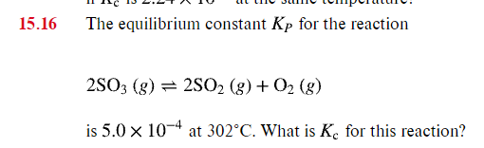
Kc= Kp
(0.0821x T) ^{Δn}

Kc= 5.0x 10⁻⁴ =1.06x 10⁻⁵
(0.0821x 575) ^{Δ1}

